General Laboratory Practices for BSL-2 Laboratories
Template (Revised 2024)
XXX Lab

Note:
This is a general template for laboratory safety procedures. The principal investigator is responsible for including laboratory and protocol specific procedures for addressing hazards in their laboratory. This plan must be adopted by the Institutional Biosafety Committee (IBC).

I have read, understand, and agree to adhere to the biosafety procedures contained within:

Printed Name Signature Date
PI:
________________ ________________ _______

Staff Trained on Manual:
________________ ________________ _______
________________ ________________ _______
________________ ________________ _______
________________ ________________ _______
________________ ________________ _______
________________ ________________ _______
________________ ________________ _______
________________ ________________ _______
________________ ________________ _______

Written (Date): _______________
Last Revision (Date): ____________
Reviewed by BSO (Date): ____________
Adopted by the IBC (Date): 9/17/07

Table of Contents

Principal Investigator Responsibilities………………………………………...… 3
Laboratory Staff/Student Responsibilities……………………………………..... 3
General Emergency Information……………………………………….………... 4
Emergency Contacts……………………………………….……………………. 4
Fire Alarms/Extinguishers……………………………...……….……………….. 4
Eyewashes……………………………………….………………………………. 4
Spills in the Laboratory……………………………………….…………………. 5
Biological Spill……………………………………….………………………….. 5
Spills Outside the Biosafety Cabinet……………………………………….……. 5
Spills Inside the Biosafety Cabinet…………………………………………..….. 5
Spills Inside Equipment……………………………………….…………………. 5
Chemical Spill……………………………………….…………………………… 6
Radiation Spill ……………………………………….………………...………… 6
Exposures in the Laboratory……………………………………….……………. 7
Biological Exposure……………………………………….…………………….. 8
Chemical Exposure……………………………………….……………………... 8
Radiation Exposure……………………………………….……………………... 8
BSL-2 Safety Procedures……………………………………….……………….. 8
New Employees……………………………………….………………………… 9
Training……………………………………….…………………………………. 9
Medical Surveillance……………………………….……………………………. 10
PPE……………………………………….……………………………………… 10
Biohazard Warning Signs and Posting……………………………………….….. 10
Biological Safety Cabinets (BSC’s) ……………………………………….……. 11
Biological Waste Disposal……………………………………….……………… 11
Chemical Safety……………………………………………………………….… 12
Fume Hood Use……………………………………….………………………… 12
Housekeeping………………………………………………………………….… 12
Laboratory Close Outs/Equipment Disposal……………………………………. 12
Security……………………………………….…………………………………. 13
Select Agents/Toxins………………………………………………………….… 13
Sharps……………………………………….…………………………………… 13
Shipping Biological Material……………………………………….…………… 13
Transporting Biological Material……………………………………….……….. 13
Useful Web Sites……………………………………….………………………... 14
Appendix A……………………………………….…………..…………………. 15
Appendix B……………………………………….……………………………… 15
Appendix C……………………………………….……………………………… 15

Principal Investigator Responsibilities

The Principal Investigator (PI) has the primary responsibility for ensuring that their laboratory is safe. They must adhere to all guidelines and regulations. They are responsible for the safe use of biological, chemical and radioactive materials in their laboratory.

In addition, the PI must:

Limit personnel, student, and visitor exposure to hazards to the lowest practical level.

Provide special safety considerations for individuals under the age of 18

Apply the recommended biosafety level for the work being conducted

Be familiar with the required medical surveillance for each type of agent in their laboratory and ensure staff/students/visitors have medical clearance

Develop written lab specific safety procedures and train their personnel on them

Maintain documentation of training

Provide PPE and instruction on use

Ensure waste is properly disposed

Report spills, exposures or incidents to Environmental Health & Safety (EHS)

Conduct periodic drills of emergency procedures

Laboratory Staff/Student Responsibilities

Know the biological materials and procedures used in the laboratory

Follow approved lab procedures and safety guidelines

Know emergency procedures

Complete all required training before conducting any lab activity

Report any unsafe conditions to the PI, EHS or the RRT

Utilize all required Personal Protective Equipment (PPE)

Use appropriate lab equipment and containment facilities

General Emergency Information

Emergency Contacts

Office Cell (After Hours)
PI
Lab Supervisor
Other
EHS
Rapid Response Team
Zone Shop
Emergency Repairs (After hours)

If there is an emergency, call 911 to reach UTPD. UTPD will then summon assistance from the City of Austin Emergency Services. If there is a fire or explosion that you cannot control, evacuate the area immediately. Pull the fire alarm and then call 911 from a safe location. For other emergencies, dial 911 for UTPD.

If any emergency or significant spill/exposure occurs in the laboratory, immediately notify EHS and your lab supervisor/PI.

Fire Alarms/Extinguishers

Locations of fire pull station alarms:

Location of fire extinguishers:

Know the location of each of these, and identify the location of the extinguisher closest to your lab bench. If the fire alarm sounds, leave the building immediately and move away to a safe distance.

Eyewashes

Location of eyewashes:

In case of exposure, proceed to nearest eyewash station. Hold eyelids open with thumb and forefinger and rinse for at least 15 minutes. Wash from the outside edges towards the inside to prevent washing chemicals back into the eye.

Rinse should be aimed at the inner corner of the eye (near the nose) not directly at the eyeball. “Roll” eyes around and up and down to ensure full rinsing.

Contact lenses (if worn) should be removed as soon as possible. Have another member of the lab call for emergency response immediately. The area around the eye wash station must remain clear at all times.
Spills in the Laboratory

Call EHS when a significant spill occurs. A lab incident report form (EHS) must be filled out for significant spills.

A significant spill is defined as:

- Spills greater than 5 mL (BSL-2, toxic chemicals) outside primary containment
- Spills that result in an exposure
- Spills that present an inhalation hazard
- Spills that cannot be easily cleaned
- Spills that endanger people or the environment

Biological Spills

Location of spill kit:

Notify your laboratory supervisor/PI and nearby lab staff. Use appropriate PPE when cleaning. Dispose of all cleanup material as biohazardous waste.

Spills Outside the Biosafety Cabinet

Decontaminate biological spill by covering the spill with paper towels and soaking in a fresh 10% bleach solution or disinfectant for at least 20 minutes.

Clean area at least 2 feet around spill with disinfectant. (Including furniture/walls)

Spills Inside the Biosafety Cabinet

Decontaminate any biological spill by covering the spill with paper towels and soaking in disinfectant for at least 20 minutes.

While spill is soaking, wipe down all work surfaces and equipment in BSC with disinfectant. Place all cleanup material into biohazardous waste container.

Spills Inside Equipment

If the spill occurs in a shaker or centrifuge, turn off the equipment and leave the door closed for at least 30 minutes to reduce aerosol exposure before cleaning up the spill.

Tape a sign indicating the problem and your name to the contaminated equipment until the situation has been rectified.

Chemical Spills

Location of spill kit:

Clean up all chemical spills immediately.

If you spill a hazardous material and need assistance, call EHS.

Radiation Spills

Location of spill kit:

Wipe up the spill with Lift-away and check for residual contamination by performing a wipe test (tritium or carbon-14) of the affected area. Monitor with a portable Geiger counter capable of detecting the energy signature of the radioisotope.

For other radioisotopes, refer to the EHS Radiation Safety Manual for proper detection methods.

Call EHS if you need assistance.

Exposures in the Laboratory

All exposures must be reported to the PI and to EHS.

Biological Exposure

Remove any contaminated clothing/jewelry and wash skin exposed to the agent with a disinfectant such as antibacterial soap.

Autoclave any contaminated clothing before disposal. Decontaminate any surfaces using the procedure for a biohazardous spill.

If you believe you may have been exposed to an agent, contact EHS and seek immediate medical attention.

If you suspect you have a lab-acquired illness regardless of a recent exposure, see a health care professional immediately. Provide the health care professional with EHS contact information to allow for coordination with the university safety office.

Fill out a worker’s compensation form even if you are not sure if your illness was acquired at work. This must be done if you need to file a claim later.

Chemical Exposure

For most chemical exposures to the skin, wash the chemical off with water for at least 15 minutes and remove any contaminated clothing. Use the sink for small exposures; for large exposures use the safety shower.

Location of safety shower:

Radiation Exposure

For skin contamination with radioactivity, wash it off and remove any contaminated clothing. If you believe you have inhaled or ingested any radioactivity, call EHS.

BSL-2 Safety Procedures
This lab is rated as Biological Safety Level 2. BSL2 is required for work involving agents of moderate potential risk to personnel and the environment.
Eating, drinking and smoking are prohibited in BSL-2 laboratories. For additional requirements consult Biosafety in Microbiological and Biomedical Laboratories (5th ed.):
http://www.cdc.gov/OD/ohs/biosfty/bmbl5/bmbl5toc.htm
Types of Biohazards or Potentially Infectious Materials:
  - Human, animal and plant pathogens:
    - Bacteria, including those with drug resistance plasmids
    - Rickettsiae
    - Fungi
    - Viruses, including oncogenic viruses and viroids
    - Parasites
    - Prions
  - All human and/or non-human primate blood, blood products, tissues and certain body fluids.
  - Cultured cells (all human and certain animal species) and potentially infectious agents these cells may contain.
  - Biological toxins (bacterial, fungal, botanical, etc.)
  - Certain recombinant products
  - Infected animals and animal tissues
Biohazardous Materials: Provide a description of material used in the laboratory in Appendix A. Include symptoms/hazards/medical surveillance for working with the material.
Potentially Hazardous Equipment: Provide a description of potentially hazardous equipment used in the laboratory in Appendix B. Examples include sonicators, blenders, lypholizers, Bunsen burners, etc…
Special Practices: Provide a description of potentially hazardous procedures conducted in the laboratory in Appendix C. Examples include culture extraction, centrifugation, use of sharps, etc…
New Employees
Location of lab manual:
Laboratory personnel should be aware of the potential hazards associated with the work and be proficient in the specified practices and procedures.
Know the chemicals you are working with. Look up the material safety data sheet (MSDS) available at http://www.utexas.edu/safety/ehs/msds/index.html. Place a bookmark on your computer so that you can access this information quickly.
For biological agents, see http://www.phac-aspc.gc.ca/msds-ftss/index.html.
If you are using a piece of equipment for the first time, please ask for instructions.
Training
All laboratory research personnel must take institutional provided training. Training must be documented (electronic or paper). Personnel should not initiate research until training is completed.
Classes:
OH101: General Hazard Communication
OH102: Site-Specific Hazard Communication (provided by the PI)
OH201: General Laboratory Safety
OH202: Hazardous Waste Management
FF205: Fire Extinguisher Training
OH207: Biological Safety
CW512 (Online): IBC Training: NIH Guidelines
Additionally if researchers are working with radiation:
OH301 Basic Radiological Health
OH302 Basic Radiological Health Refresher
Before working with human blood or tissues:
OH218: Bloodborne Pathogens for Lab Personnel
Medical Surveillance
List all medical requirements: (pre-placement physical, immunization, baseline serum, periodic surveillance, exposure response, exit evaluation)
Anyone who is pregnant, has a medical condition, or who is taking medication that increases the risk of acquiring laboratory infections must inform the PI and should consult with EHS.
All medical surveillance must be documented.
PPE
List all PPE to be used in the lab: (gloves, lab coats, gowns, booties, eyewear, face protection, respirators)
EHS recommends that non-latex gloves be used.
Biohazard Warning Signs and Posting
Each laboratory must clearly display a sign that provides safety information to visitors and service personnel. EHS will provide the signs.
    - All areas and laboratories which contain biohazardous agents must be posted with a biohazard sign. The sign must be red/orange in color with a biohazard symbol and lettering in black.
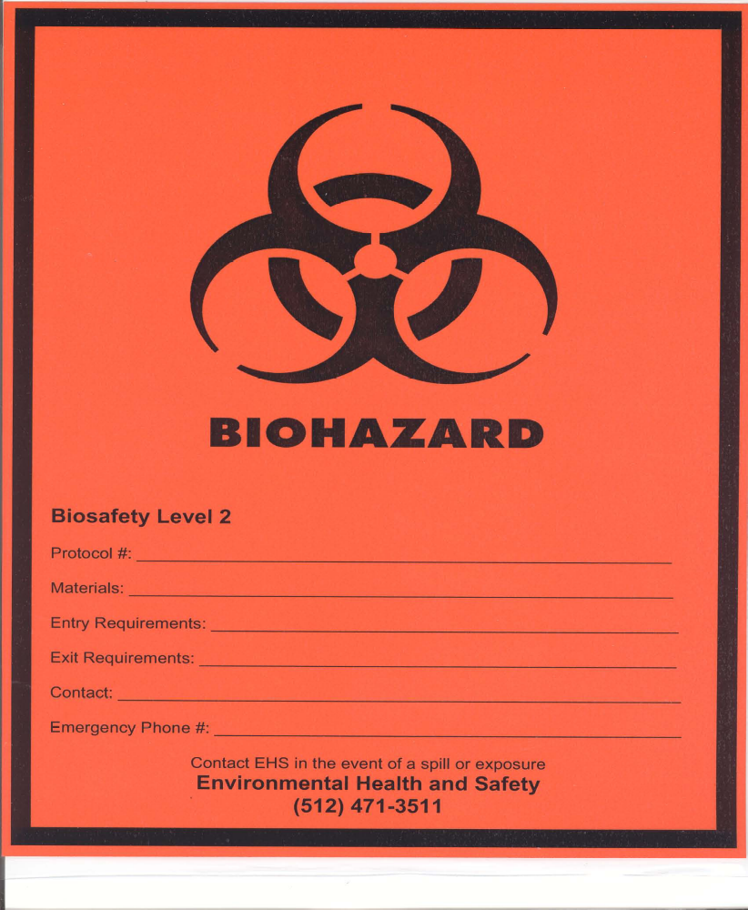

    - The sign must have information regarding biosafety level, materials used, entry requirements, exit requirements, emergency contact name and phone number.
Biological Safety Cabinets (BSC’s)
There is no requirement for directional inward airflow in a BSL-2 laboratory, except as may be required for chemical odor control.
BSC’s should be positioned in the laboratory away from normal traffic patterns to minimize airflow disruption.
Some work may be done on the open bench by persons wearing appropriate protective clothing or gear. Any work that may produce splatters or aerosols of infectious materials should be done inside a biological safety cabinet (BSC) or other containment device.
Before materials are introduced into the BSC, they should be wiped with disinfectant to remove any external contaminants.
Clean materials should be kept to one side of the work surface, dirty items on the other. Management of workflow within the BSC is crucial to preventing cross-contamination.
Rapid air movement outside the cabinet (caused by co-workers walking past, air supply vents directed across the face of the BSC, etc.) will interrupt the rather fragile air curtain, which may cause air-borne contaminants in the cabinet to be drawn into the lap of the worker.
The chair should be adjusted so that the lower portion of the sash is even with the worker’s armpits.
Any paper or plastic materials introduced into the BSC should not be allowed to interfere with air flow through the front or rear grilles.
The downward airflow from the supply filter "splits" about one third of the way into the cabinet; in the front third, air moves to the front grille, with the remainder of the air flowing to the rear. This means that aerosol-generating activities should be performed towards the rear of the cabinet to provide further worker protection.
Biological Waste Disposal
All recombinant material is considered infectious and must be disposed as biological waste.
Liquid infectious waste materials should be chemically disinfected with 10% bleach or Bacdown detergent disinfectant or, preferably, decontaminated in a steam autoclave. Solid, non-sharp infectious waste should be placed in a biohazard autoclave bag or in a biohazard box if being picked up by EHS.
If autoclaving waste, tie the bag closed or use a rubber band, place in an autoclave pan, and autoclave for at least 30 minutes at 121°C under 15 psi. Sign the autoclave record log and after cycle completion, place EHS waste treatment sticker on the bag, and place in a black trash bag before disposing in the regular trash.
Autoclaves need to be tested with biological test packs. The frequency is determined by the amount of waste produced. For information, contact EHS. For problems with the autoclave, call 471-1718 or call maintenance at 471-6188.
Chemical and Radioactive Materials
No agarose or polyacrylamide should be disposed of in the sink. Polymerized agarose and polyacrylamide should be discarded in the trash. Unpolymerized polyacrylamide should be polymerized and placed in the trash.
Label all containers with a minimum of the contents, date, and your initials.
When using radioactive compounds, sign the radioactive log on the wall next to the isotope refrigerator. Always use plastic backed paper on the bench, wear and change gloves frequently, and wear a lab coat designated only for use with radioactivity.
Waste materials need to be segregated into chemical, radioactive, bio-hazardous, or general waste streams.
Fume Hood Use
Use organic and volatile compounds in the fume hood. Discard organic waste (phenol, chloroform) in appropriate bottles in the fume hood. Keep waste tags attached to waste containers and identify the contents. Submit the Request for Disposal form to EHS for waste pick-up.
Housekeeping
Special practices include: decontaminating work surfaces after completing the work with the infectious materials, keeping non-research animals out of the laboratory, and reporting all spills and accidents.
Laboratory Close Outs/Equipment Disposal
Labs that use biological material must notify EHS to ensure the laboratory has been properly decontaminated.
Any laboratory equipment for disposal or surplus must be decontaminated. Contact EHS for information or on the web at http://www.utexas.edu/safety/ehs/lab/labcleanout.html

Security
Access to the laboratory is restricted. The door to the laboratory is kept closed and locked to minimize unnecessary access by casual visitors, vendors, or other persons to the laboratory.
Select Agents/Toxins
Research involving Select Agents/Toxins is regulated by the CDC. Any researcher that possesses select agents/toxins must notify EHS. Researchers that want to work with select agents/toxins must notify EHS to begin the registration process.
Sharps
Extreme precautions should be taken while handling needles and other sharp instruments. In any situation, do not break or bend needles; use single-use needles and syringes.
Do not recap needles. Needles and syringes, butterfly needles and associated tubing, and similar devices should be discarded intact into a sharps container. Do not fill these containers more than ¾ full.
Safe needles devices should be used when possible. Safety devices such as needle or scalpel guards or retractable devices should be employed. Blunt needles or transfer pipettes should be used instead of needles to reduce exposure.
Broken glass should not be handled by hand, but should be disposed of with a broom and dustpan or tongs. Non-contaminated glass should be disposed of in the cardboard “glass” containers.
What steps to take following a sharps injury:
- Provide immediate care at the exposure site: Promptly attend to the injury, encouraging bleeding at the puncture site. Wash puncture wounds thoroughly with soap and water for 15 minutes.
- Evaluate exposure and report: Assess the extent of the exposure and promptly report the incident.
  - Seek medical care: Consult a healthcare professional to determine the risks associated with the exposure. Swift action is crucial as hazardous chemicals or infectious materials present on sharps or within the syringe may lead to secondary health effects, and timely response helps mitigate the risk of serious illness.
  - Reporting to EHS: Immediately report all injuries or exposures involving sharps to Environmental Health and Safety (EHS) at 512-471-3511 after seeking medical care. EHS will review the circumstances of the exposure incidents to prevent future injuries and determine if the submission of the Texas Department of State Health Services, Infectious Disease Control, Contaminated Sharps Injury Reporting Form to the local Health Department is necessary. Refer to the institutional BLOODBORNE PATHOGENS EXPOSURE CONTROL PLAN for comprehensive instructions.

Shipping Biological Material
The shipping of infectious materials is regulated by DOT/IATA. Shipments must be completed by a certified shipper. Permits may also be required. Contact EHS for additional information. Material Transfer Agreement forms will also likely be required. Contact the Office of Sponsored Projects for more information.
Transporting Biological Material
A leak proof box, preferably equipped with a gasket seal lid, should be used for transport of infectious materials from one location to another.

Useful Web Sites
NIH Guidelines:
http://www4.od.nih.gov/oba/rac/guidelines/guidelines.html
BMBL:
http://www.cdc.gov/od/ohs/biosfty/bmbl5/bmbl5toc.htm
NIH Office of Biotechnology Activities:
http://www4.od.nih.gov/oba/
CDC Select Agents Program:
http://www.cdc.gov/od/sap/index.htm
CDC Permit to Import or Transport Etiologic Agents:
http://www.cdc.gov/od/ohs/biosfty/imprtper.htm
USDA/APHIS Permit to Import or Transport Livestock Pathogens:
http://www.aphis.usda.gov/animal_health/permits/
USDA/APHIS Permit to Field Test, Import, or Transport Genetically Modified Organisms:
http://www.aphis.usda.gov/brs/regulatory_activities.html
Selection, Installation, and Use of Biological Safety Cabinets:
http://www.cdc.gov/od/ohs/biosfty/bsc/bsc.htm

Appendix A
Biohazardous Summary Statement: Provide a description of materials used in the laboratory in Appendix A. Include symptoms/hazards/precautions for working with these materials.
Attach Biosafety MSDS if available:
http://www.phac-aspc.gc.ca/msds-ftss/index.html
Appendix B
Potentially Hazardous Equipment: Provide a description of potentially hazardous equipment used in the laboratory in Appendix B. Examples include sonicators, grinders, blenders, lyophilizers, centrifuges, Bunsen burners, etc…
Appendix C
Special Practices: Provide a description of potentially hazardous procedures conducted in the laboratory in Appendix C. Examples include culture extraction, centrifugation, overtaxing, use of sharps, etc…

