(Insert name of chemical/process/experiment here)
Standard Operating Procedure Rev Date: 12/09/2021

This standard operating procedure (SOP) outlines required methods to be used by researchers during this outlined experiment or process. These practices and procedures are intended to provide a safe working environment, promote a culture of forward-thinking risk mitigation, and to promote compliance with federal, state, and local regulations.
APPLICABILITY
This SOP is for processes, experiments, or manipulations that pose moderate risks and that call for protective steps beyond those dictated by accepted laboratory standards. They are intended to limit the potential for injury, equipment damage, or environmental impact
This SOP is not applicable to….
RESPONSIBILITIES (Add to list as appropriate)
PI/Supervisor:
- Implement the guidance outlined in this document within departmental/institute operations.
- Provide training to laboratory personnel regarding the specific hazards involved in working with (enter name of substance here) to include work area decontamination, and emergency procedures prior to conducting any work.
- Provide laboratory personnel with a copy of this SOP and a copy of the SDS provided by the manufacturer.
- Ensure that laboratory personnel have completed appropriate laboratory safety training and/or refresher training as required.
- Ensure all personnel are trained on the proper use/operation of any equipment used during the experiment or process.
- Require the use of proper lab attire (lab coats, gloves and eye protection).
Researchers (Graduate Students/Postdocs/Research Staff)
- Implement and follow minimum working protection found in this document.
- Complete appropriate laboratory safety training.
- Wear appropriate personal protective equipment that includes but may not be limited to a lab coat, gloves and eye protection in the laboratory.
- Report all near misses, incidents, and unsafe acts or conditions to the principal investigator and Environmental Health & Safety.
Undergraduate Students
- Follow minimum working protection found in this document.
- Complete appropriate laboratory safety training.
- Wear appropriate personal protective equipment that includes but may not be limited to a lab coat, gloves and eye protection in the laboratory.

PROCEDURE
Fill in all highlighted areas with appropriate information
INSERT TITLE OF EXPERIMENT OR PROCESS
This is where you can type out a description of the experiment or process you will perform. Just give an overall view. You will be walking through the experiment or process step by step below.
Preparer: Insert Name |  |  |  | Location: CPE 000.0
Authorized Personnel with Contact Information
Position |  |  |  | Name |  |  |  | Number/Email
Principle Investigator/Supervisor |  |  |  | Insert Name |  |  |  | 555-5555
Student/Technician/Operator |  |  |  | Insert Name |  |  |  | 555-5555
Others to be notified (e.g., other workers in the same laboratory, or other members of the research group) |  |  |  | Insert Name |  |  |  | 555-5555
HAZARDS, CONTROLS, CONDITIONS, & REQUIREMENTS
Potential Hazards
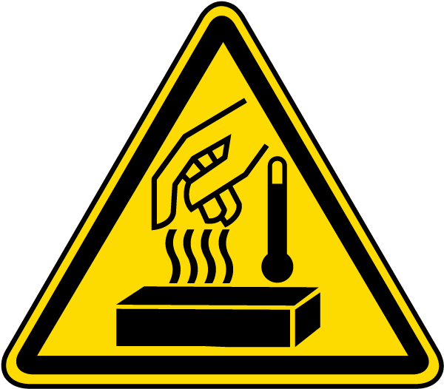
Copy and paste relevant pictograms. (Examples in attachment 1)
Planned Chemicals Involved |  |  |  | Hazards
Insert chemical name |  |  |  | List relevant hazards for chemical. (Examples in attachment 1)
Planned Equipment Involved |  |  |  | Hazards
Insert equipment name |  |  |  | List relevant hazards for equipment. (Examples in attachment 1)
Hazard Controls
Engineering |  |  |  |  |  |  | Work Practice
Examples include:  - Fume hood or glove box  - Special ventilation  - HEPA-filtered vacuum lines  - Non-reactive containers  - Pressure relief devices  - Temperature control  - Bench paper, pads, plastic-backed paper  - Special signage  - Safe sharp devices  - Guards  - Connect to ground |  |  |  |  |  |  | Examples include:  - Designated areas  - Procedures for requesting emergency assistance  - Emergency phone numbers  - Locations of fire alarms, fire extinguishers, fire blankets, eye washes, showers, etc.  - Emergency responders  - Workers on shifts  - Training on all experimental techniques and experiments  - Restricting access; locks  - Housekeeping  - Lockout/tagout a procedure plan  - After-hour procedures  - Preventive maintenance
Required PPE

Copy and paste relevant pictograms with descriptions as needed. (Examples in attachment 2)
Experiment Operational Ranges and Conditions
Pressure: |  | Insert info | Temperature: |  |  | Insert info |  |  | Volume: | Insert info
Flammability Range: |  | Insert info | Other:
Special Handling & Storage Requirements
Insert handling and storage information here
Spill & Incident Procedure
Insert spill and incident procedure here
Waste Handling & Disposal
Most spent, unused, and expired chemicals/materials are considered hazardous wastes, they must be properly disposed of. Do not dispose of chemical wastes by pouring them down a sink or drain, or discarding in the regular trash containers. Contact HMM at EHS-HazardousMaterials@austin.utexas.edu or call 512-471-3511. Euthanized animals will be disposed of according to EHS recommendations.
Contact EHS-HMM at (512) 471-3511 for waste supplies and for any questions regarding proper waste disposal. Also, refer to the EHS Hazardous Waste Web page for more information.
Training Requirements
- Complete EHS online Laboratory Safety training available through UT Learn. (https://ehs.utexas.edu/training/lab-training-requirements).
- Review SOP with knowledgeable person.
- Complete training on operation of specialized equipment prior to use (e.g., ultracentrifuge, hydrogenation apparatus).
- Other EHS training requirements (e.g., Biosafety, Radiation Safety, Hazardous Waste Management) as appropriate.
PROCEDURE
Step # | Directions
1 | Insert procedural steps for experiment or process. Add to table as needed.
2
3
4
5
6
7
VERIFICATION & REVIEW
Current Date |  |  |  |  |  | Date of SOP Expiration
00/00/0000 |  |  |  |  |  | 00/00/0000
PI Name |  |  |  |  |  | PI Signature
Insert Name
Safety Reviewer Name |  |  |  |  |  | Safety Reviewer Signature
Insert Name
LIST OF REFERENCES
Include Safety Data Sheets, Globally Harmonized System, any outside personnel consulted in preparation of document, peer reviewers, etc.

SOP Training Certification
I have read and understand the above SOP. I have taken all appropriate EHS training. I have received prior approval from my supervisor to perform this procedure. I agree to contact my supervisor if I plan to modify this procedure.
Name | Signature | UTEID | Date

Principal Investigator | Revision Date

PROCEDURE MODIFICATIONS/REVISIONS
Current Date | Modifications or Revisions | Name
00/00/0000 | Insert summary of changes made | Insert name of person making and/or approving changes
12/9/2021 | Original document | Suzanne Kilpatrick
12/9/2021 | Updates to responsibility, waste, training requirements sections and addition of SOP training certification section. | Rudy Guerrero, Andrea McNair (Reviewers: Suzanne Kilpatrick)

Attachment 1 -- Remove after use

Pictograms and Hazards
Chemical Hazards
 | - Carcinogen  - Mutagenicity  - Reproductive Toxicity | - Respiratory Sensitizer  - Target Organ Toxicity  - Aspiration Toxicity
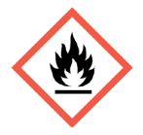 | - Flammables  - Pyrophorics  - Self-Heating | - Emits Flammable Gas  - Self-Reactives  - Organic Peroxides
 | - Irritant (skin and eye)  - Skin Sensitizer  - Acute Toxicity (harmful) | - Narcotic Effects  - Respiratory Tract Irritant
 | - Gases Under Pressure
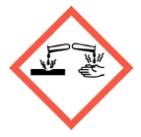 | - Skin Corrosion/Burns  - Eye Damage  - Corrosive to Metals
- Explosives
- Self-Reactives
- Organic Peroxides
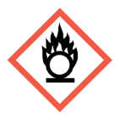 | - Oxidizers
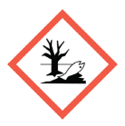 | - Aquatic Toxicity
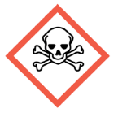 | - Acute Toxicity (fatal or toxic)
Physical Hazards
 | - Noise
 | - Moving Parts
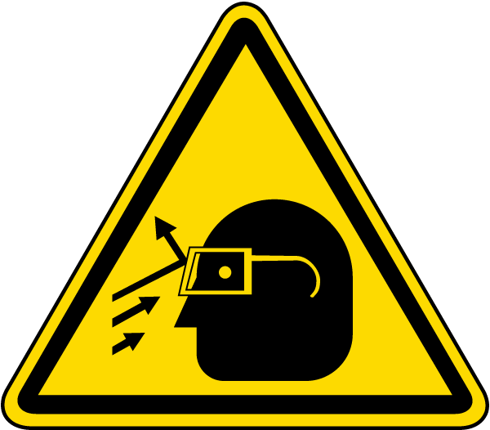 | - Projectiles
 | - Slip/Fall
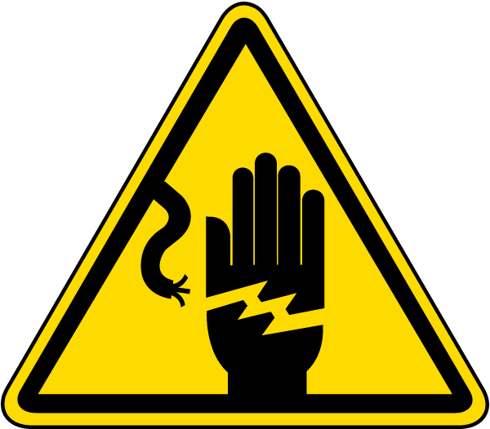 | - Electrical
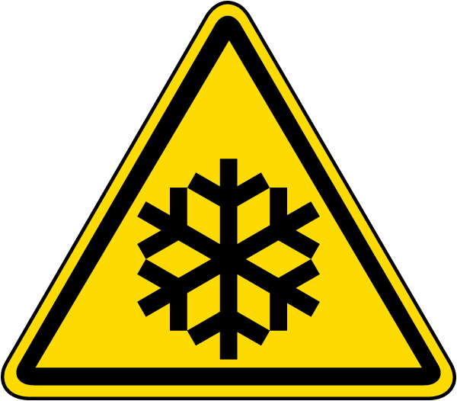 | - Low Temperature
- Hot Substance
- Hot Surface
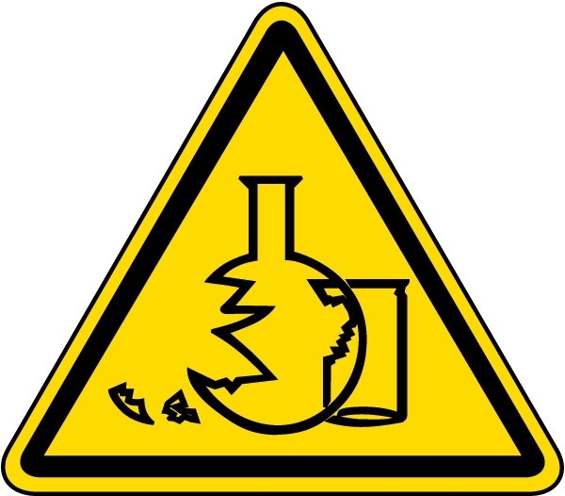 | - Glass Hazard
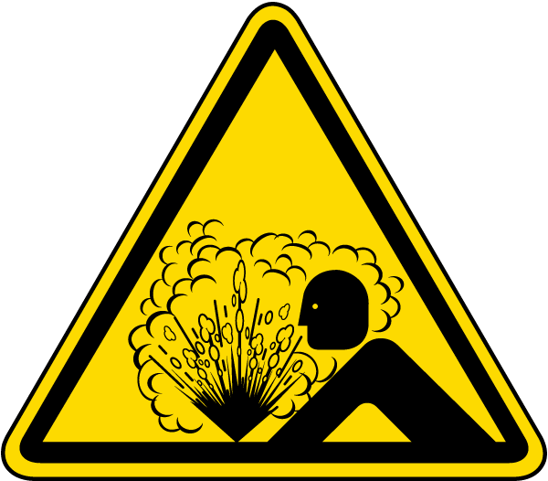 | - Pressure Release

Attachment 2 – Remove after use
Pictograms and Descriptions
Personal Protective Equipment
 | Hard Hat
Eye Protection
- Safety Glasses
- Goggles

 | Face Shield
Hearing Protection
- Ear Plugs
- Ear Muffs
- Canal Caps
Filtering Facepiece Respirator
- N/R/P95
- N/R/P99
- N/R/P100

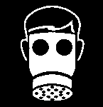 | Tight Fitting Respirator  - Half Face  - Full Face
 | Welding Hood
 | High Visibility Clothing
 | Lab Coat
Clothing protection
- Long sleeve shirt and pants
- Leather
- Fire Resistant
- Chemical Resistant
 | Gloves  - Vinyl  - Nitrile  - Cotton  - Cut Resistant | - Heat Protective  - Rubber  - Cold Protective  - Anti-vibration
Foot Protection
- Closed Toe
- Slip Resistant
- Conductive
- Safety Toe

