**Welch Hall Fire in Lab Refrigerator, 3/12**

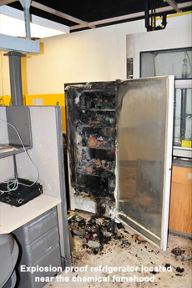What happened?

An explosion-proof refrigerator caught on fire at approximately 3:45 a.m. The heat from the fire activated the sprinkler and set off the fire alarm. The sprinklers quickly extinguished the fire but the water caused damage to the building.

What was the cause?

The exact cause of the fire was not determined. Approximately 100 chemical containers were in the refrigerator including pyrophorics, water-reactives, flammables, and oxidizers. Possible causes include refrigerator mechanical failure and/or a chemical reaction occurred in the refrigerator resulting in the fire.

What corrective actions were taken?

Standing water in lab resulting from sprinkler activation 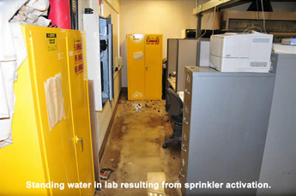

A committee was formed to identify improvements for the refrigeration of hazardous chemicals. All refrigerators in the building where the fire occurred were inventoried and assessed. Some of the more deteriorated refrigerators identified were replaced. The research groups which work with the most hazardous chemicals were visited and informed of proper refrigeration storage. Refrigeration storage guidelines and magnets were developed and distributed.

How can we prevent incidents like this?

* Researchers need to ensure only compatible chemicals are stored in a refrigerator.
* All chemical containers need to be in good condition and clearly labeled.
* Researchers should complete an inventory annually of chemicals stored in lab safe refrigerators.
* Every year researchers should defrost freezers and inspect the refrigerator and its contents.

Resources

1. Bretherick's Handbook of Reactive Chemical Hazards, 6th Edition, P.G. Urben, ed., 1999
2. [Prudents Practices in the Laboratory, Handling and Management of Chemical Hazards, National Research Council, 2011](http://www.nap.edu/catalog.php?record_id=12654)